

NAME; AMIRDHA A
REG NO: 192324072

Mobile Computing LAB
- Use Figma to create an interactive diagram illustrating the components of a basic cellular system.
Aim:
To create an interactive diagram illustrating the components of a basic cellular system

Procedure: -
- open Figma
- Create a new file
- Select the Frames
- Fill in the content that is required for presentation
- Design Visual Elements
- Make it Interactive
- Add Annotations and Explanations
- Incorporate Multimedia
- Storyboard Animation
- Review and edit the Prototype
- Save and Share

Design: -
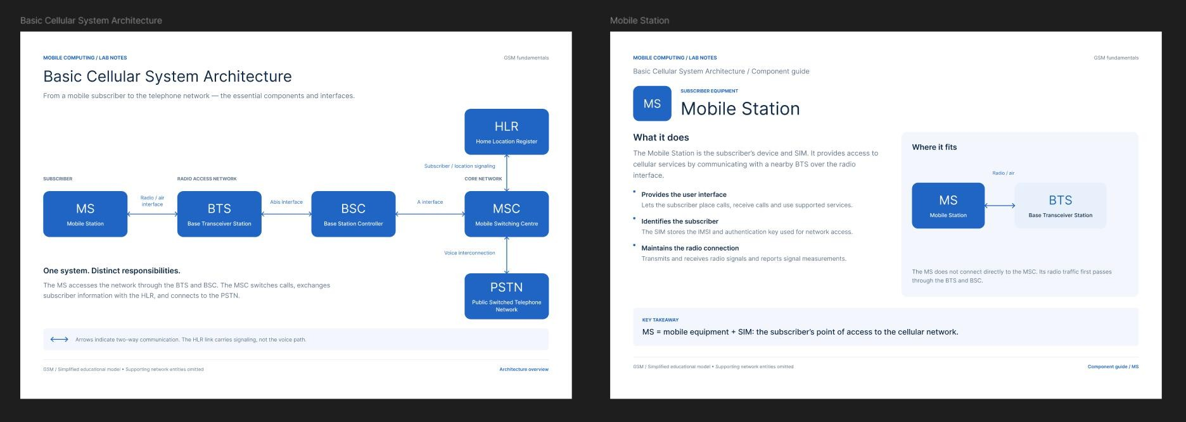

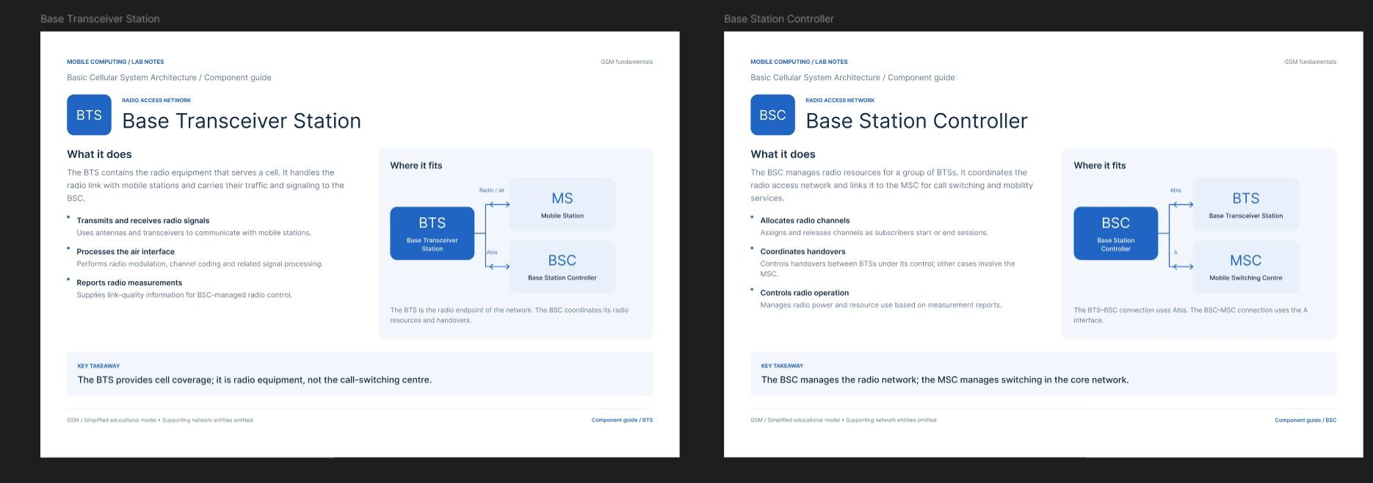
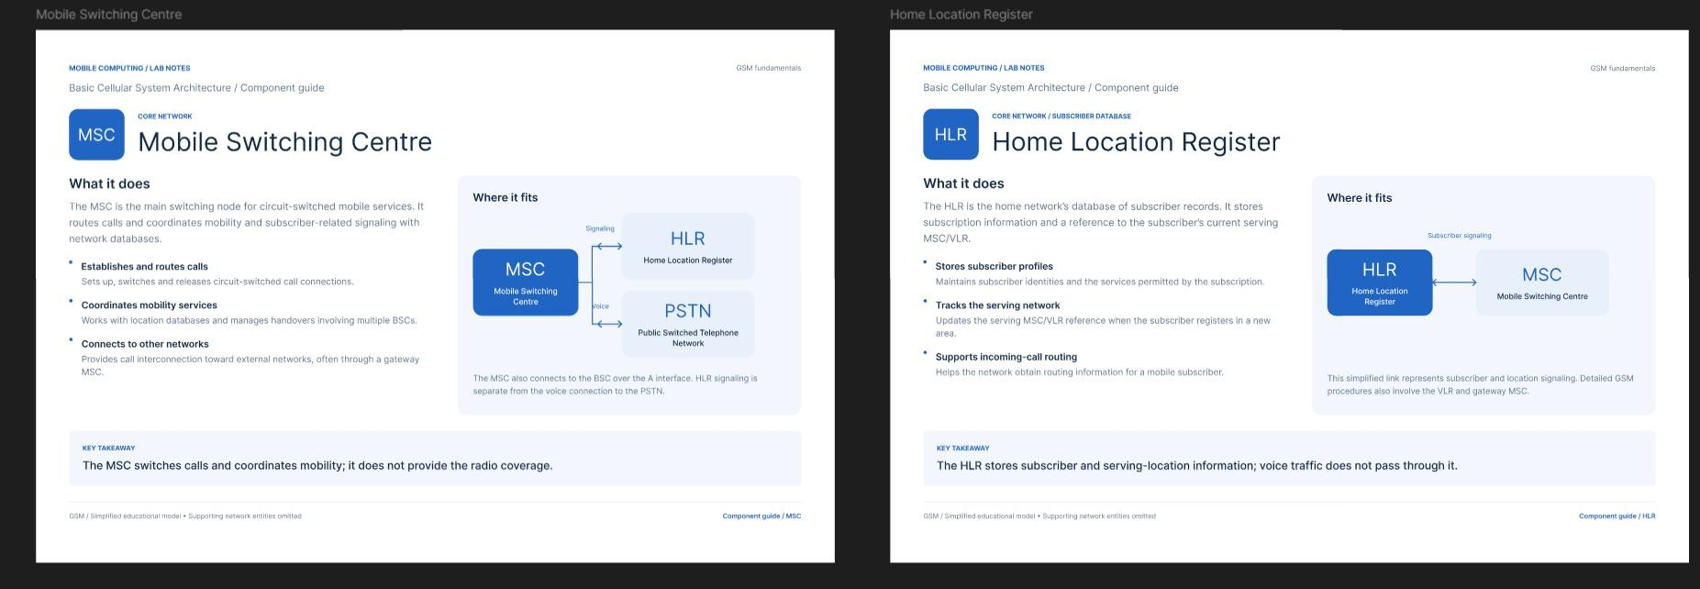
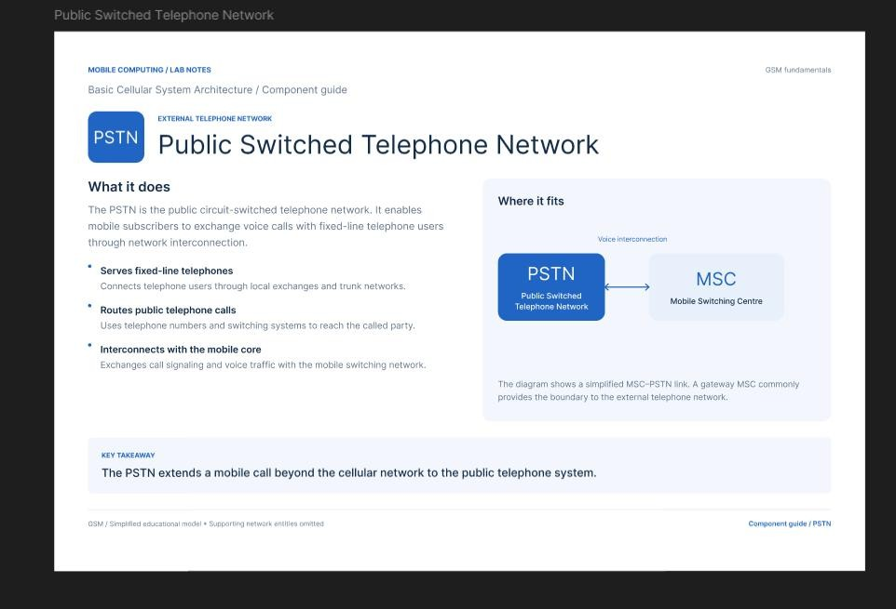

Result: -
Hence an interactive diagram illustrating the components of a basic cellular system using Figma is created and executed successfully

Design a user interface prototype for a mobile station using Figma, considering connectivity and convenience.
Aim: -
To create a user interface prototype for a mobile station using Figma, considering connectivity and convenience.

Procedure: -

- open Figma
- Create a new file
- Select the Frames
- Design Visual Elements
- Make it Interactive
- Add icons on the Frame
- Incorporate Multimedia
- Storyboard Animation
- Review and edit the Prototype
- Save and Share

Design:-
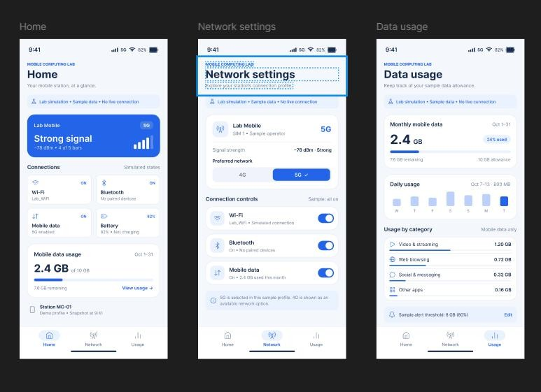

Result: -
A user interface prototype for a mobile station using Figma, considering connectivity and convenience using Figma is created and executed successful

Develop a flowchart in Figma depicting the operation of a Network Switching Subsystem in a mobile cellular system.

Aim: -
To draw a flowchart in Figma depicting the operation of a Network Switching Subsystem in a mobile cellular system

Procedure: -
- open Figma
- Create a new file
- Click on the resources icon and click on the plugins
- Search for the Flow Chart
- Drag and drop the shapes on the screen
- Now, enter the content on the shapes and connect them through Arrows.
- Grouping and alignment
- Review and edit
- Save and share

Design: -
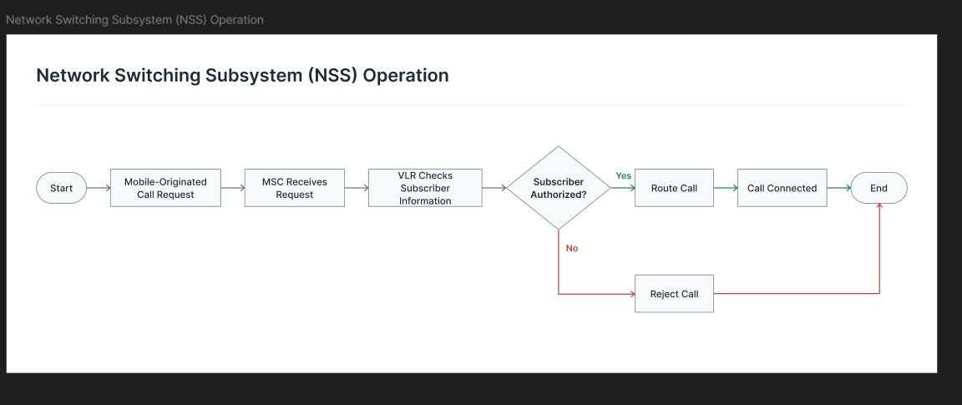

Result: -
Hence the flowchart in Figma depicting the operation of a Network Switching Subsystem in a mobile cellular system has been drawn successfully.

Create a visual representation in Figma highlighting the key elements of mobile network protocol stacks.

Aim: -
Design a visual representation in Figma highlighting the key elements of mobile network protocol stacks.

Procedure: -
- open Figma
- Create a new file
- Select the Frames
- Fill in the content that is required for presentation
- Design Visual Elements
- Make it Interactive
- Add Annotations and Explanations
- Incorporate Multimedia
- Storyboard Animation
- Review and edit the Prototype
- Save and Share

Design: -
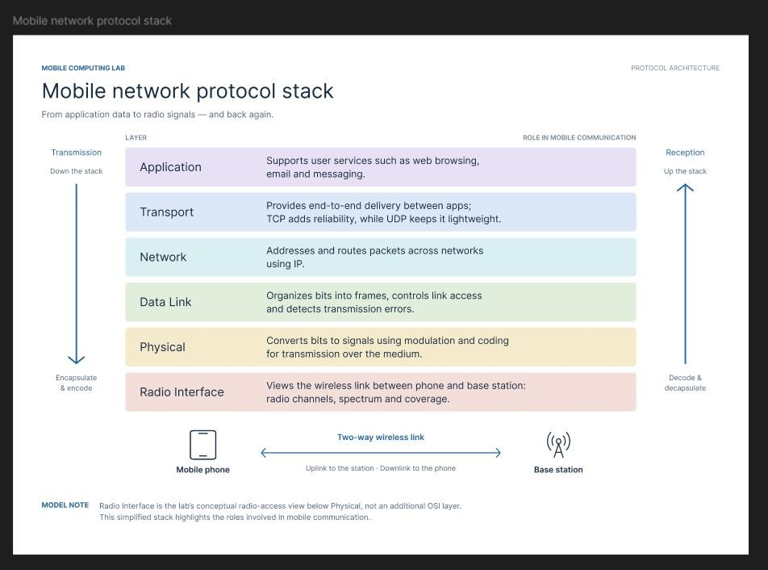

Result: -
Hence the visual representation in Figma highlighting the key elements of mobile network protocol stacks is created and executed successfully

Design a wireframe for a mobile application that incorporates localization features using Figma.

Aim: -
To design a wireframe using Figma for a mobile application that incorporates localization features

Procedure: -
- open Figma
- Create a new file
- Select the Frames
- Design Visual Elements
- Make it Interactive
- Add icons on the Frame
- Incorporate Multimedia
- Storyboard Animation
- Review and edit the Prototype
- Save and Share

Design: -
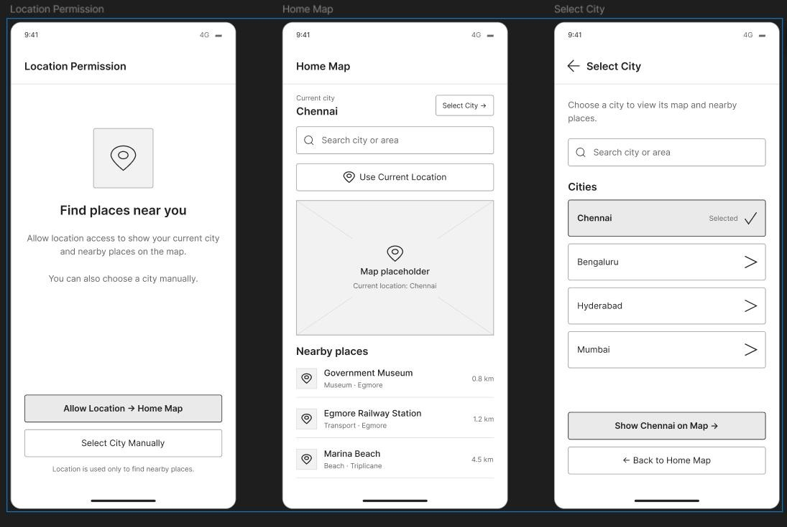

Result: -
Hence the wireframe for a mobile application that incorporates localization features using Figma is created and executed successfully
- Use Figma to simulate a handoff scenario in a mobile network and visualize the process. Aim: -To simulate a handoff scenario in a mobile network and visualize the process using Figma. Procedure:
  - Open Figma
  - Create a new file
  - Select the Frames
  - Fill in the content that is required for presentation
  - Design Visual Elements
  - Make it Interactive
  - Add Annotations and Explanations
  - Incorporate Multimedia
  - Storyboard Animation
  - Review and edit the Prototype
  - Save and Share

Design:
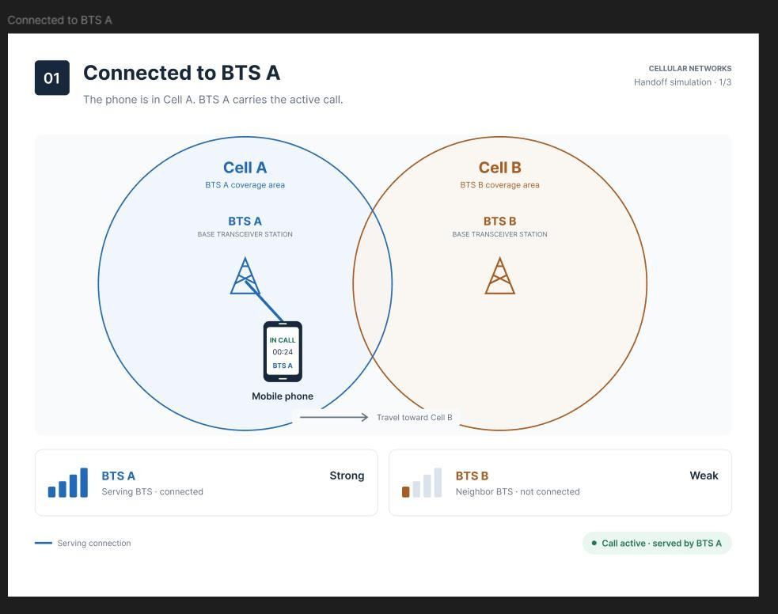

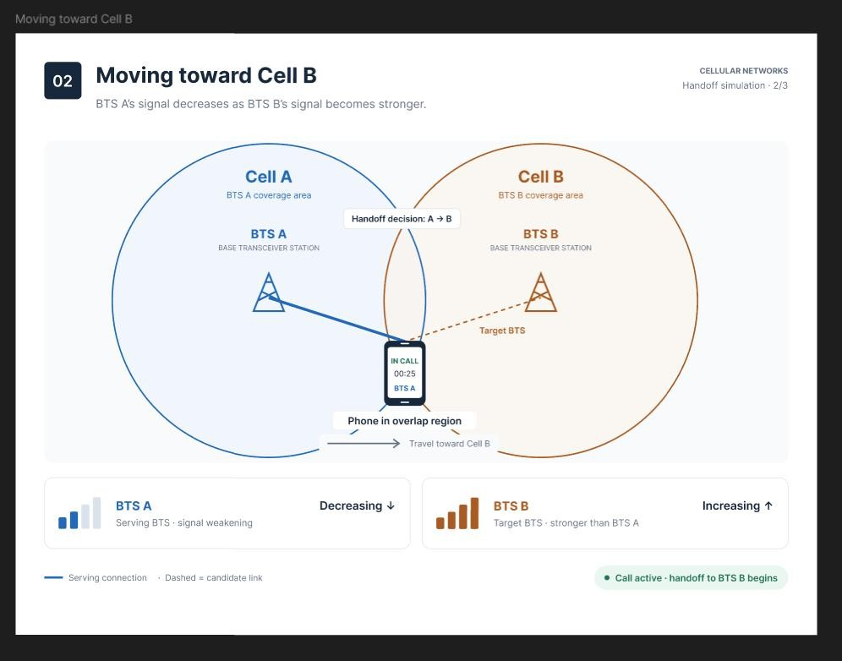
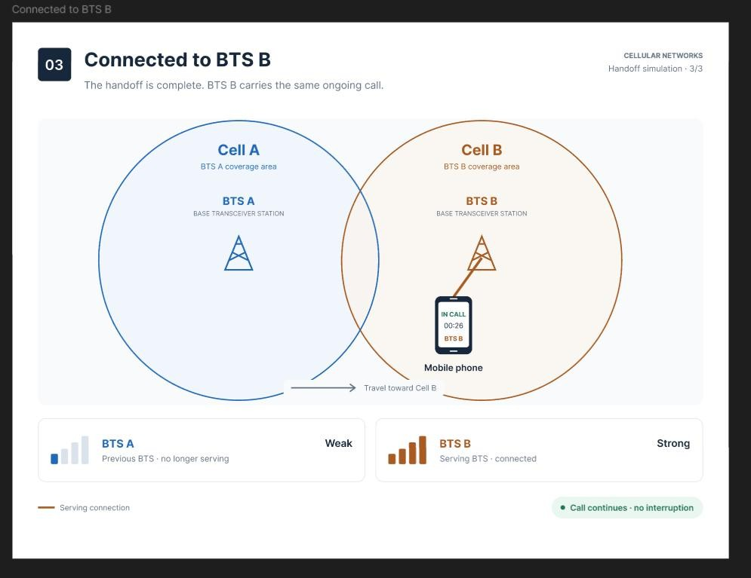

Result:
Hence the simulated a handoff scenario in a mobile network and visualized the process using Figma.

Develop a dashboard prototype in Figma displaying performance criteria for a cellular system.

Aim: To develop a dashboard prototype in Figma displaying performance criteria for a cellular system.

Procedure:
- Open Figma
- Create a new file
- Select the Frames
- Fill in the content that is required for presentation
- Design Visual Elements
- Make it Interactive
- Add Annotations and Explanations
- Incorporate Multimedia
- Storyboard Animation
- Review and edit the Prototype
- Save and Share

Design:
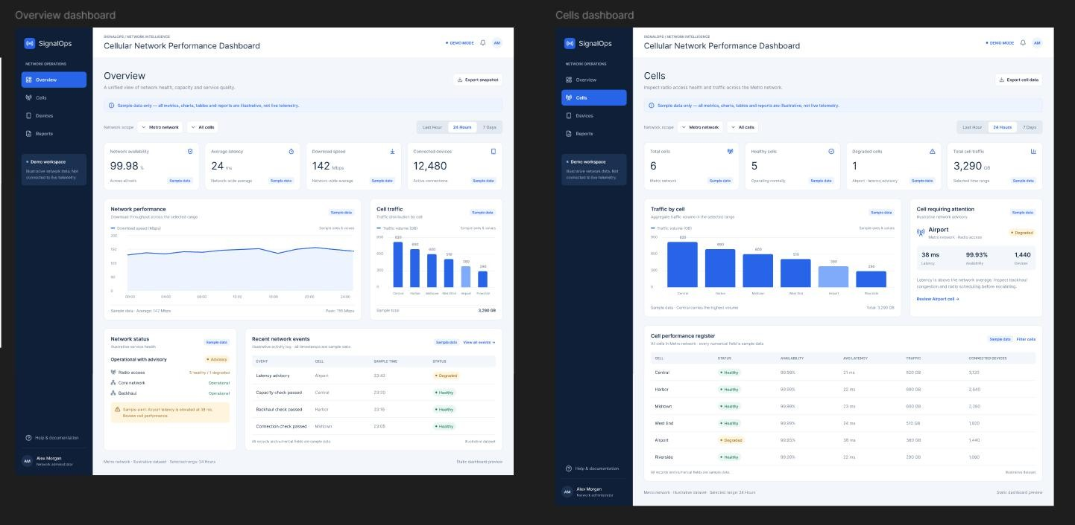

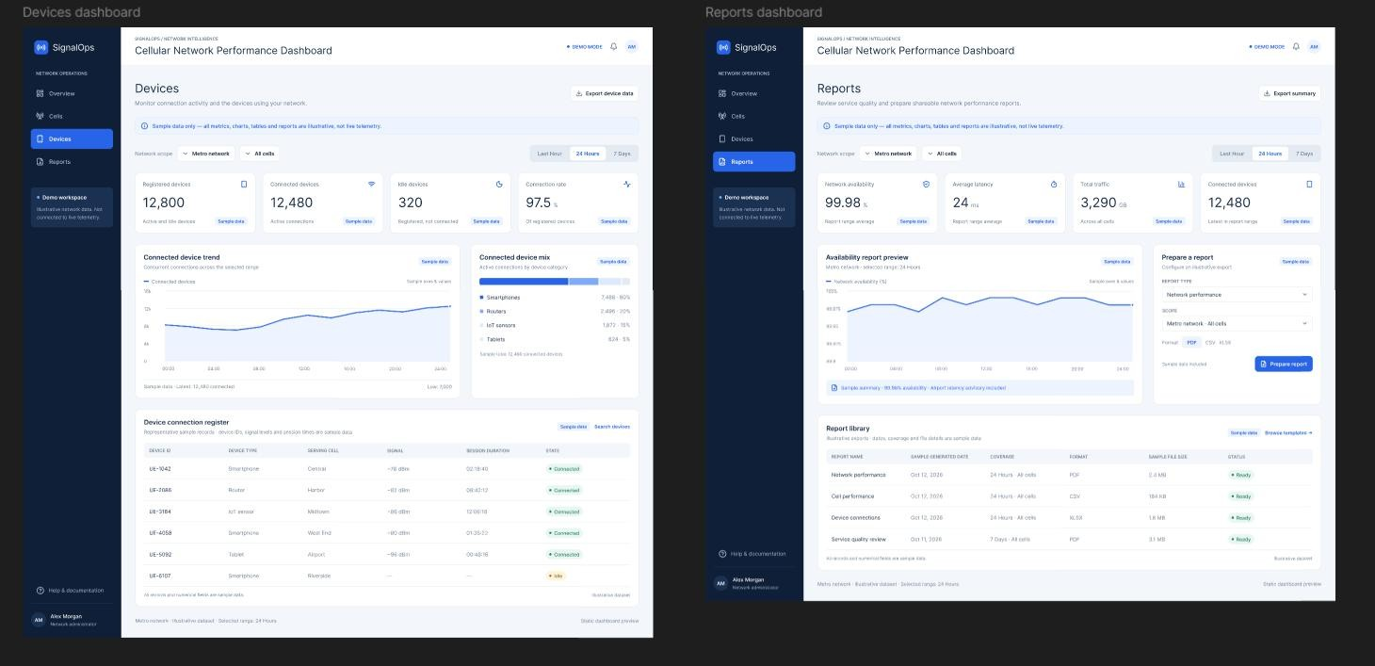

Result:
Hence developed a dashboard prototype in Figma displaying performance criteria for a cellular system.

Create an infographic in Figma explaining the concept of Public Land Mobile Network (PLMN).
Aim: To create an infographic in Figma explaining the concept of Public Land Mobile Network (PLMN).

Procedure:
- Open Figma
- Create a new file
- Select the Frames
- Fill in the content that is required for presentation
- Design Visual Elements
- Make it Interactive
- Add Annotations and Explanations
- Incorporate Multimedia
- Storyboard Animation
- Review and edit the Prototype
- Save and Share

Design:
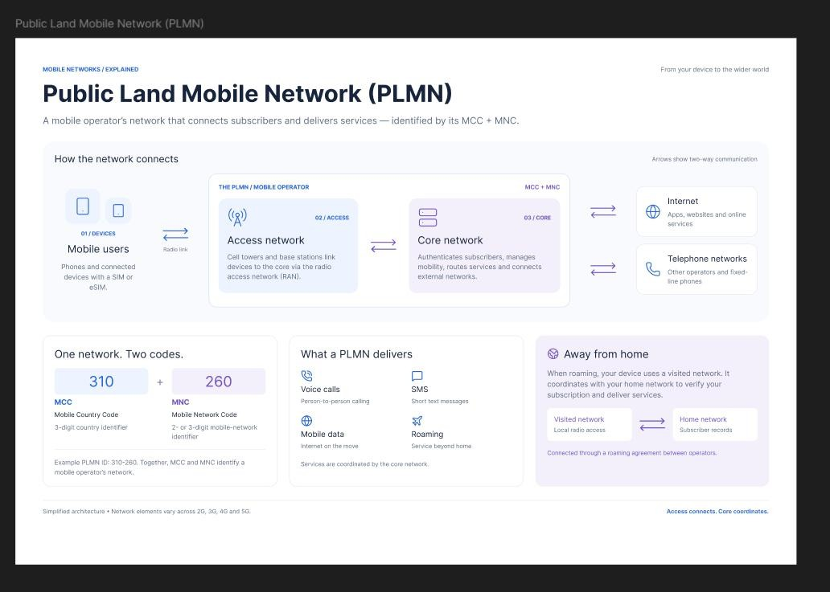

Result:
Hence created an infographic in Figma explaining the concept of Public Land Mobile Network (PLMN).

- Develop a user interface prototype for a GSM service using Figma. Aim: To develop a user interface prototype for a GSM service using Figma.

Procedure:
- Open Figma
- Create a new file
- Select the Frames
- Fill in the content that is required for presentation
- Design Visual Elements
- Make it Interactive
- Add Annotations and Explanations
- Incorporate Multimedia

- Storyboard Animation
- Review and edit the Prototype
- Save and Share

Design:
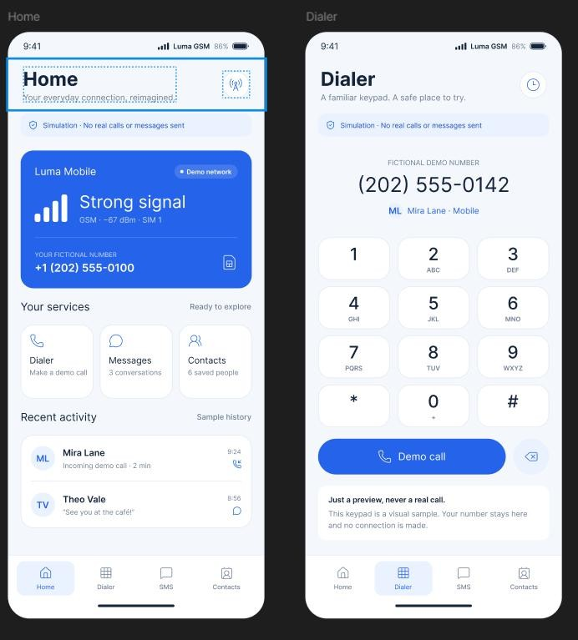
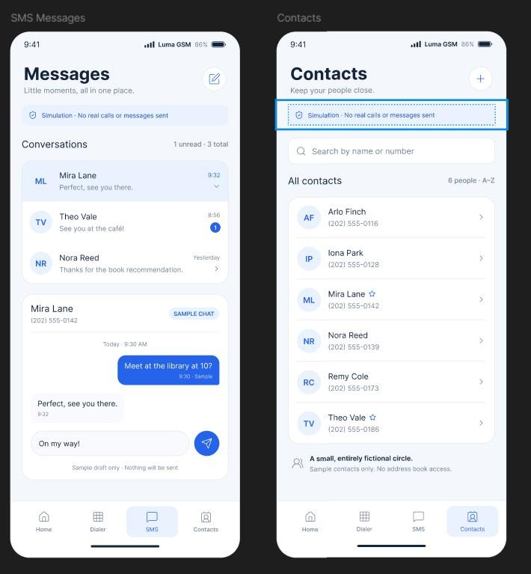

Result:
Hence developed a user interface prototype for a GSM service using Figma.

Create a visual representation in Figma showcasing the differences between various multiple access techniques.
Aim: To create a visual representation in Figma showcasing the differences between various multiple access techniques.

Procedure:
- Open Figma
- Create a new file
- Select the Frames
- Fill in the content that is required for presentation
- Design Visual Elements
- Make it Interactive
- Add Annotations and Explanations
- Incorporate Multimedia
- Storyboard Animation
- Review and edit the Prototype
- Save and Share

Design:
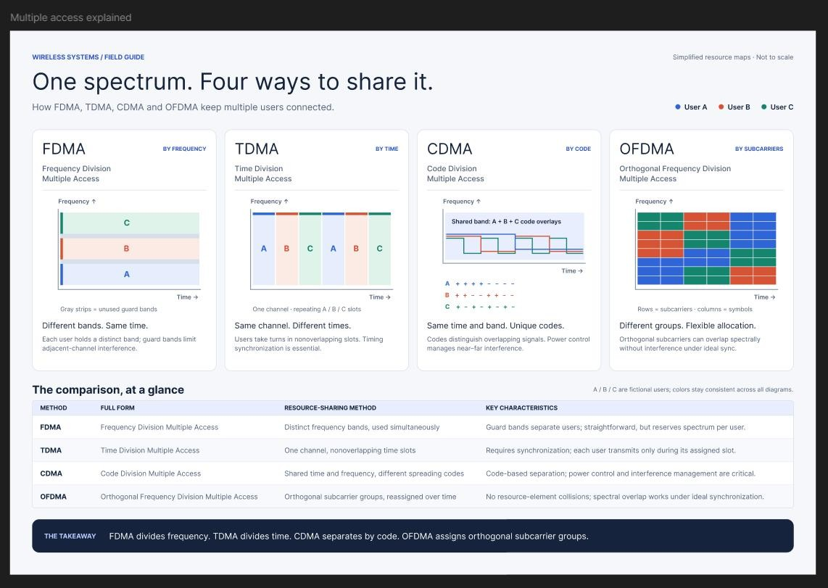

Result:
Hence created a visual representation in Figma showcasing the differences between various multiple access techniques.

